Amazon AWS VPC Introduction and Features

# What is AWS VPC?

AWS VPC or Virtual Private Cloud is an Amazon service that allows you to create you own virtual network inside Amazon cloud and to use this virtual network to launch amazon resources.

This virtual network closely resembles a traditional network that you'd operate in your own data center, with **the benefits of using the scalable infrastructure of AWS.**

You can think of a VPC as your own network of machines and databases that live completely inside Amazon’s infrastructure but can be managed as if they were in your own data center. Here’s a diagram of a how a typical VPC setup looks like

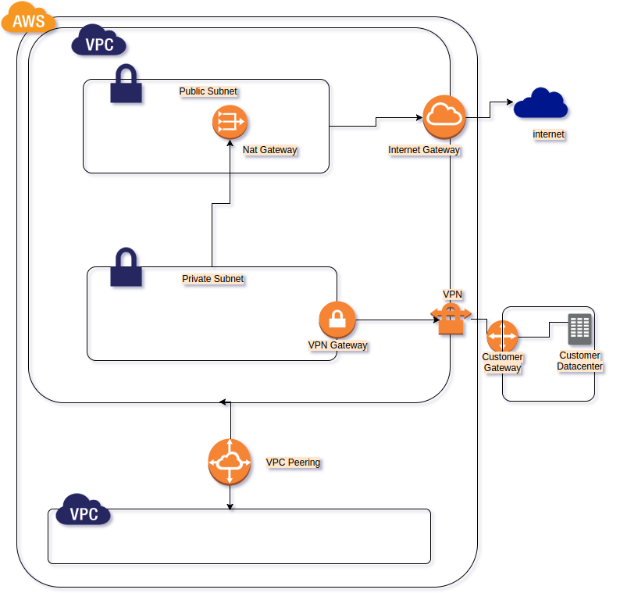

As you get started with Amazon VPC, you should understand the key concepts of this virtual network, and how it is similar to or different from your own networks.

Amazon VPC is the networking layer for Amazon EC2.

